Exercise 7: Financial Forecasting
Scenario:
You are developing a financial forecasting tool that predicts future values based on past data.

Program:
FinancialForecast.java
package dsa.finacialforecasting;

public class FinancialForecast {
public static double calculateFutureValue(double presentValue, double growthRate, int years) {
if(years == 0)
return presentValue;

double previousYearValue = calculateFutureValue(presentValue,growthRate,years-1);
return previousYearValue * (1 + growthRate);
}

public static void main(String[] args) {
System.out.println("=== Financial Forecasting ====");

double initialInvestment = 10000.0;
double annualGrowth = 0.07;
int forecastYears = 10;

System.out.println("\nInitial Investment: "+initialInvestment);
System.out.printf("Expected Annual Growth: %.2f" ,(annualGrowth * 100));
System.out.println("\nForecasting horizon: " + forecastYears + " years");

double predictedValue = calculateFutureValue(initialInvestment,annualGrowth,forecastYears);

System.out.printf("\nPredicted Value: %.2f",predictedValue);
}
}

Output:
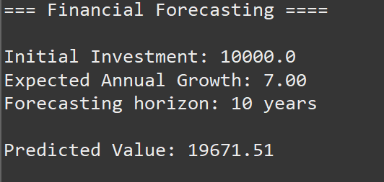

Analysis:
Time Complexity: O(n) where ‘n’ is the number of years. The function executes exactly once for every year forecasted. If you forecast 10 years, it makes 10 recursive calls.

